**Hasil Screenshoot Bruno Exercise Back-End**

Nama : Vanessa Simanta

NPM : 535230030

Kasus 1 : create user awal

Kasus 2 : update user

Kasus 3 : update user dengan email yang sama (ada duplicate email)

Kasus 4 : create user dengan adanya confirm password

Kasus 5 : create user tetapi saat confirm password, password berbeda

Kasus 6 : change password

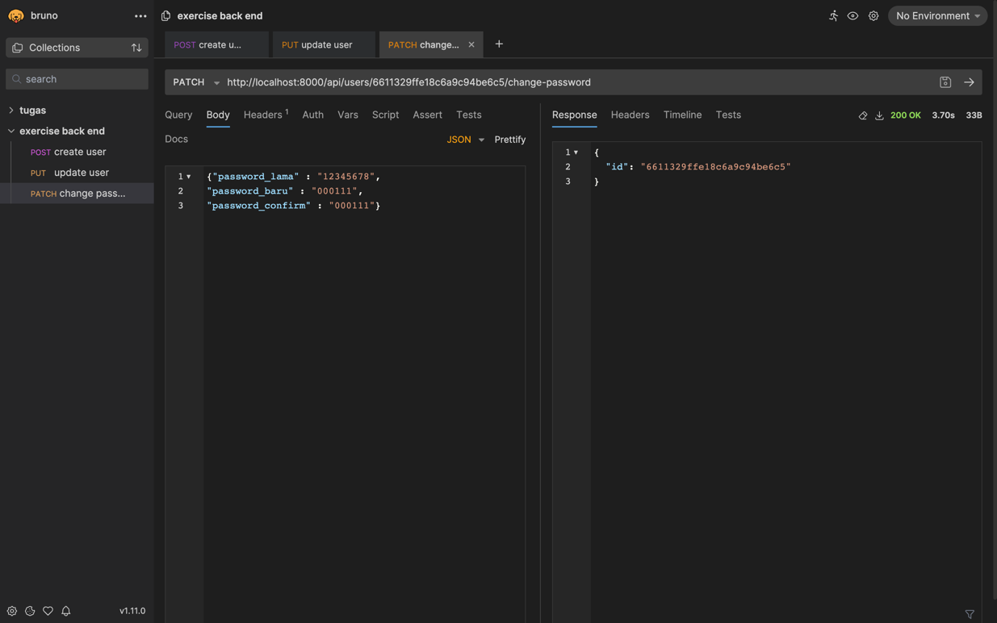

Kasus 7 : change password tetapi password lama berbeda dengan yang sebelumnya (yang di database)

Kasus 8 : change password tetapi password baru dengan password confirm berbeda

Kasus 9 : change password tetapi password length kurang dari 6

